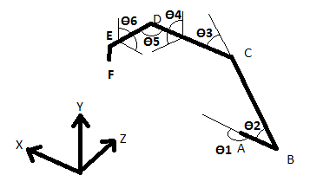

Angle: Starting Location: Direction

Θ1 X axis Counterclockwise to -Z

Θ2 D1 lll D2 Clockwise from D1

Θ3 D2 ll D3 Counterclockwise from D2

Θ4

Θ5 D3 lll D4

Θ6

Point: Location:[U] Orientation:{V}

A (0,0,0) cos(Θ1)i– sin(Θ1)k

B D1{A} -cos(Θ2){A}+ sin(Θ2)j

C D2{B}+[B] -cos(Θ2- Θ3){A}+sin(Θ2 – Θ3)j

D D3{C}+[C]

E D4{D}+[D]

F D5{E}+[E] {E}

l=cos(Θ2- Θ3)cos(Θ1)i +sin(Θ1)j –cos(Θ2- Θ3)sin(Θ1)k

m= cos(Θ1)sin(Θ2- Θ3)i- cos(Θ2- Θ3) j- sin(Θ1) sin(Θ2- Θ3)k

n=-sin(Θ1)i –cos(Θ1) k

Unit vectors l, m, and n are to be used to find the orientation of D and E.

Velocity is simply the time derivative of the position.

Some of the theta primes are not equal to the omegas, but have ratios that need to be factored in.